**Bachelor of Software Engineering**

**Centre for IT Education (CITES)**

**Department of Electrical and Computer Engineering**

**The Open University of Sri Lanka**

**EEI3346 – Web Application Development**

**Mini Project Submission**

**Student Number: S92066603**

**Student Name: A. Mohammed Asky**

**Task 01: Web Design**

Create a website that displays Tourist information about Sri Lanka. This must contain all the well-known tourist places. It can be named *“Pearl of the Indian Ocean”* and it should contain an appropriate theme. Users could be able to browse Province/District wise information as well; it would be appreciated if you add other details like general information of SL and contact details of the service providers, etc.

The page should contain at least **5 distinct web pages**, should have a captivating look, and be interactive. Some suggestions for pages are Home, about us, separate pages for tourist information, queries, To-Do List and Contact Us.

**Guidelines:**

1. You are free to decide on suitable pages, images, and their components as long as the basic requirements of the website are met.
2. **Create a To-Do list using VueJs** where users can enter their preferences (i.e: they can enter the list of the places where they planned to visit.), once they complete it, the list should display separately by the side of the same page.
3. **Usages of Templates are** prohibited. Make sure to avoid irrelevant components/information.
4. You are advised to use **CSS, JavaScript, and VueJs framework** to improve the look and feel of the website.
5. Backend functionality is NOT expected to be implemented.
6. E-commerce integration is NOT expected.
7. Marks will be distributed for the correct usage of HTML, CSS, JavaScript, and Vue Js

**Task 02: Documentation** *(All required documents are added to a folder, zip it and upload to the LMS.)*

The documentation should describe your implementation covering the following areas.

1. Frontpage (with your basic details)
2. Problem(s) – sub-problems, constraints
3. Solution Approach - How you plan to solve the identified sub-problems
4. Architectural diagram of the system
5. Site Map
6. Used web technologies and examples
7. Test Results (test cases with screenshots and descriptions)
8. Conclusion

**Description of the first page**

* My webpage is for tourists visiting Sri Lanka. This website offers the best places in a particular district. I have also added HTML, CSS, Java script and Vue Js to create this website. Customers can also mark places they want to visit in the coming days. You can do this yourself in the do section and I used Vue Js.
* I added an image to the homepage background to make the website realistic. I have added pictures for the best places in the district. I have added videos at the end of each district for tourists to learn more about those great places. I have also added a query using JavaScript, which will be useful for tourists to ask for any help and send comments. Contact Us and Contact Us Provides information about the website and the way to contact them, respectively.

# **Problems faced**

* We did not know about Vue Js at the time the mini project was given. It was hard to read Vue Js and finish the website in that short time. The Vue Js tutorial link is given on our LMS page, but it was difficult to understand the tutorial due to lack of explanation.

**Solutions to the above problems**

* They held a workshop about Vue Js. That workshop was very helpful to complete our mini project.
* I watched some YouTube videos on how to create a webpage. Those YouTube videos helped me complete this mini project.

# Site Map

Home Page

Home

Hotel

Beaches

Places

Uva Tourism

Historical

About Us

Contact

Contact form

Hottels

Uva Tourism

Most Beautiful places

Contact us

About us

Historical page

Uva Tourism page

Place Page

Beach Page

Hotel page

Historical places

Historical page

Beaches Page

Beaches

Nature

Nature Page

Sore Da

To Do Page

**Used Web Technologies**

1. HTML : To Crate Main Framework
2. Css : To add styles and beautify the web pages
3. Vue Js : In order to save the places where the user goes

**Results**

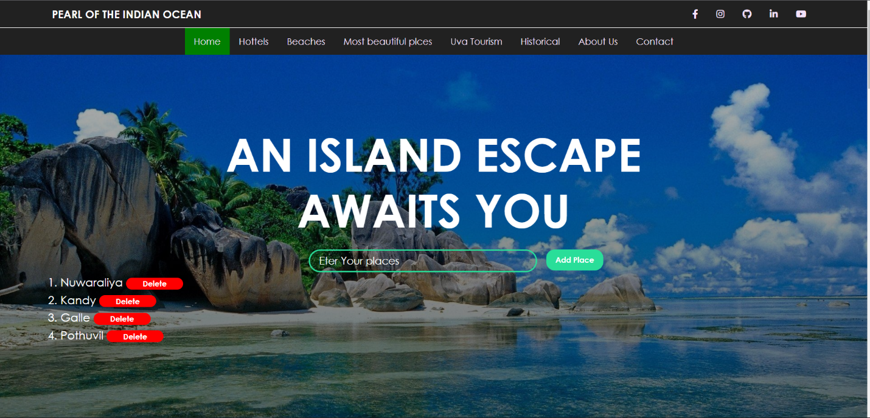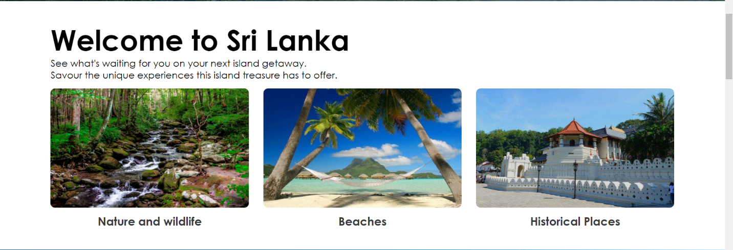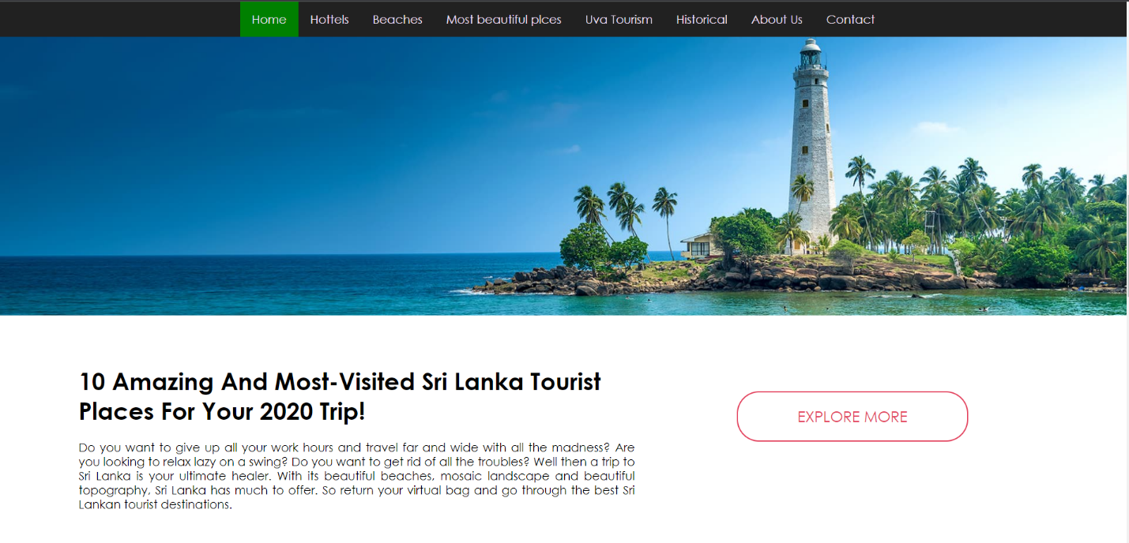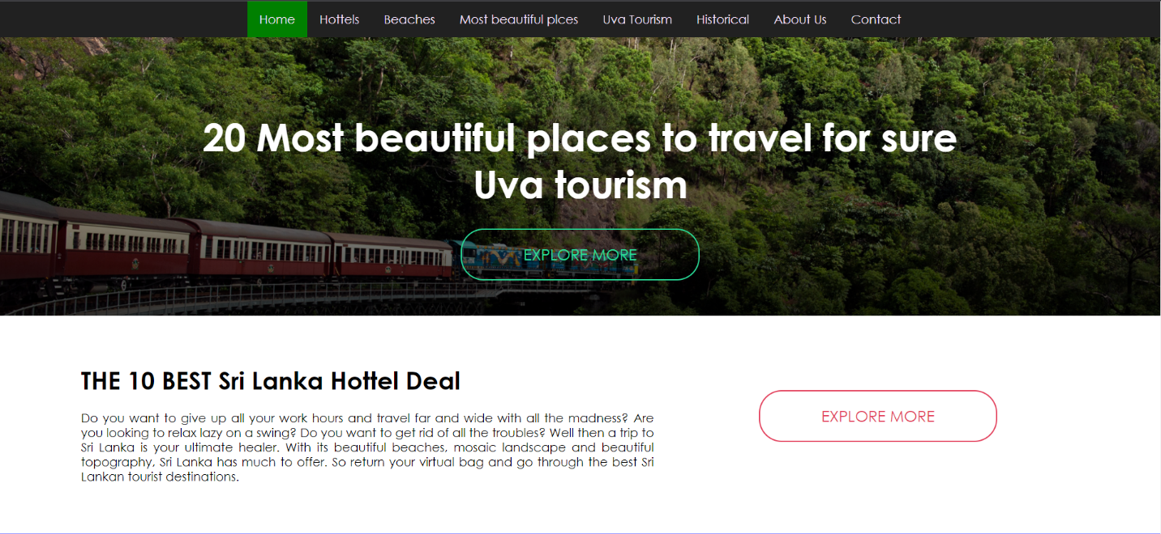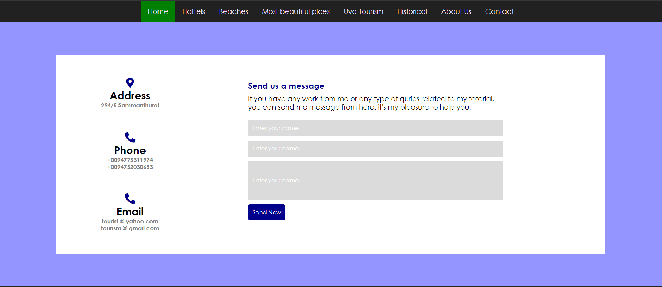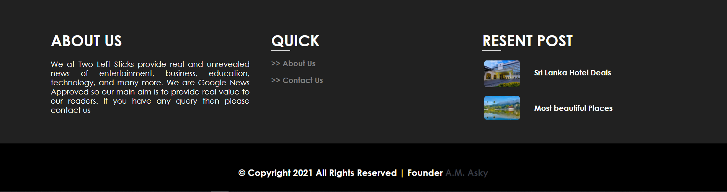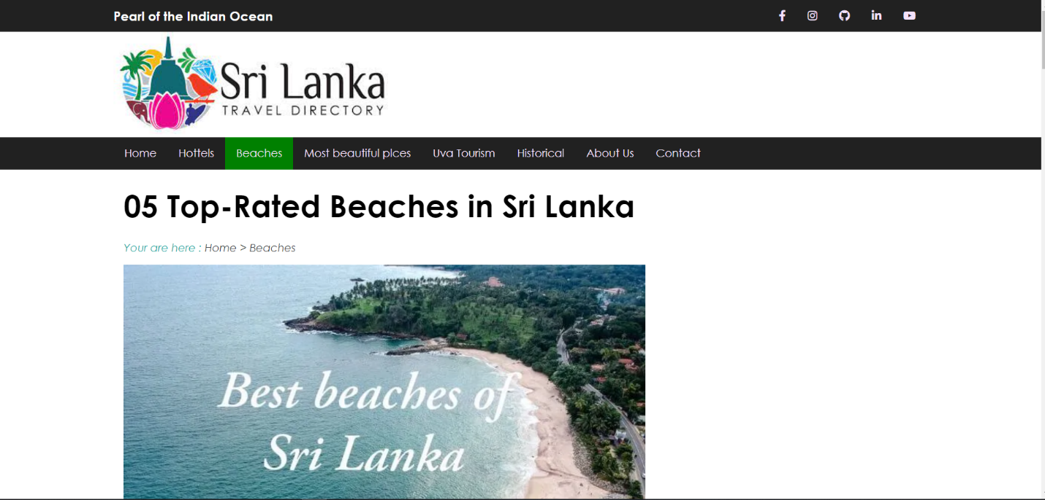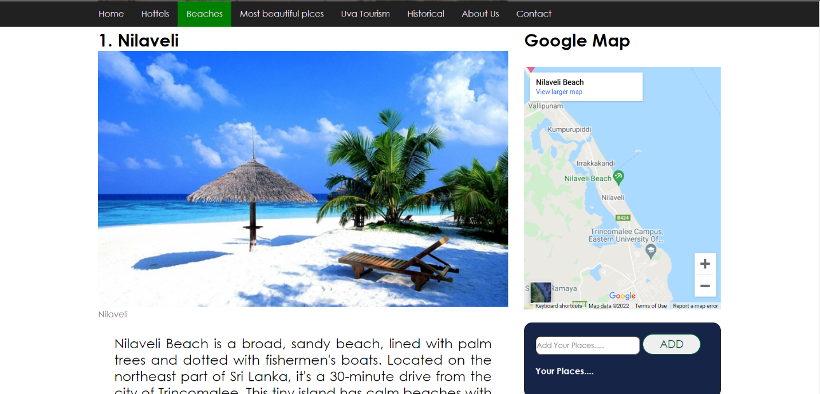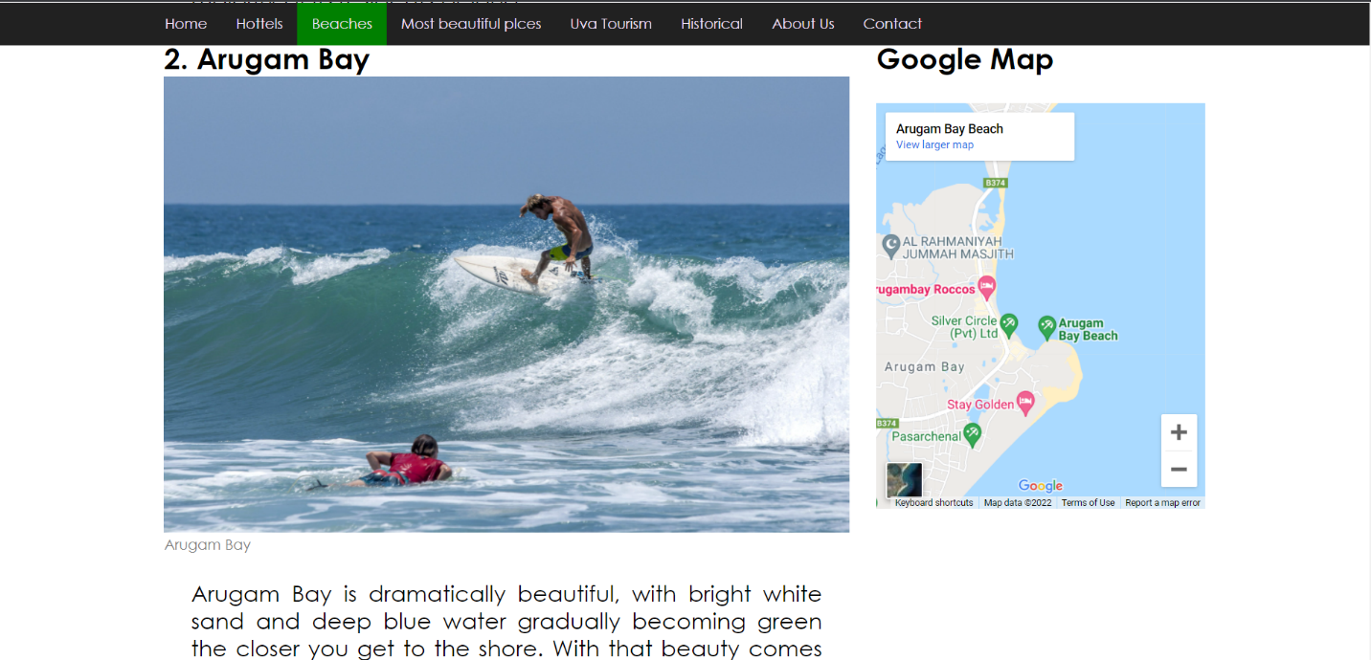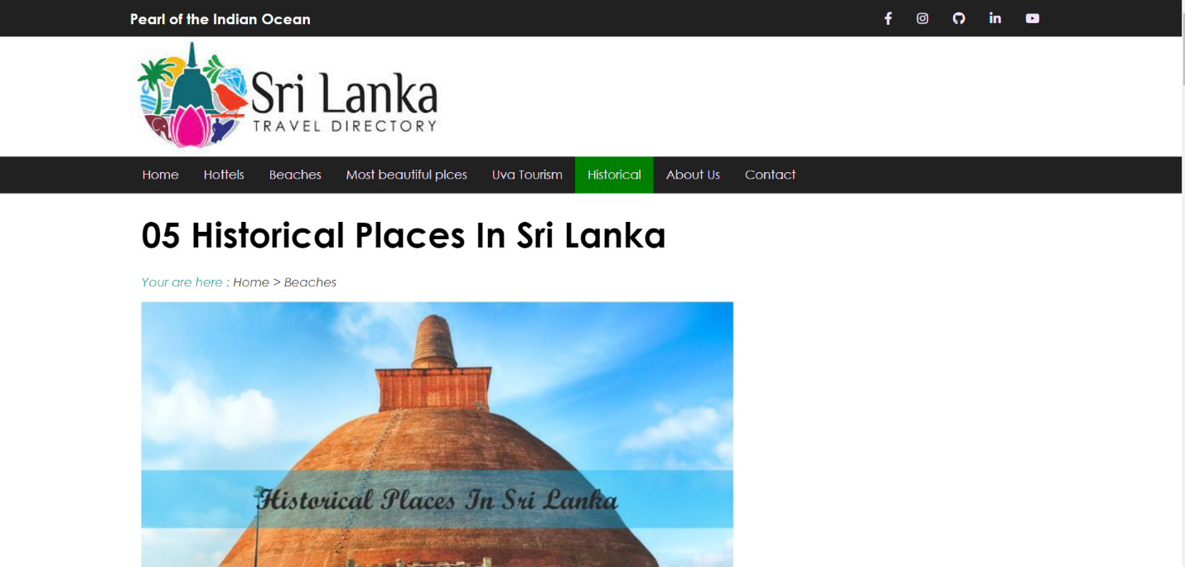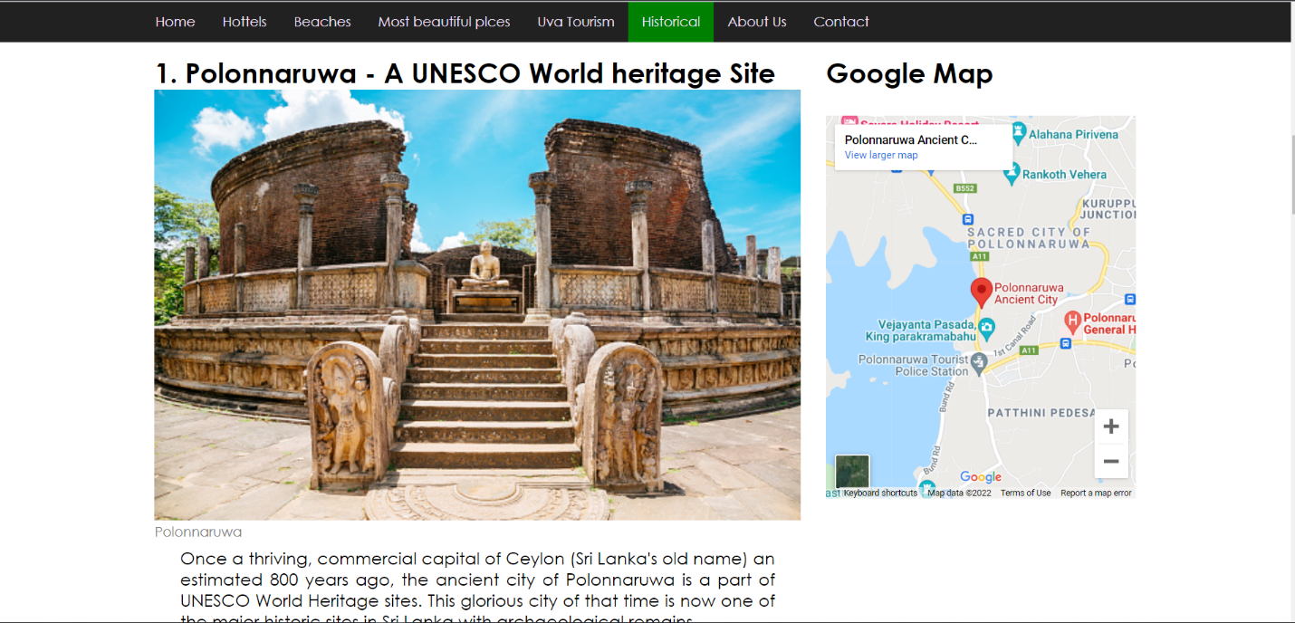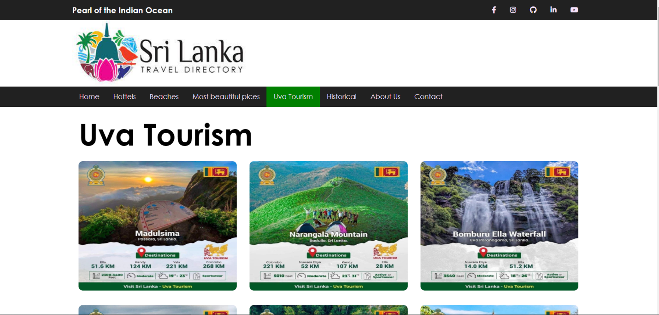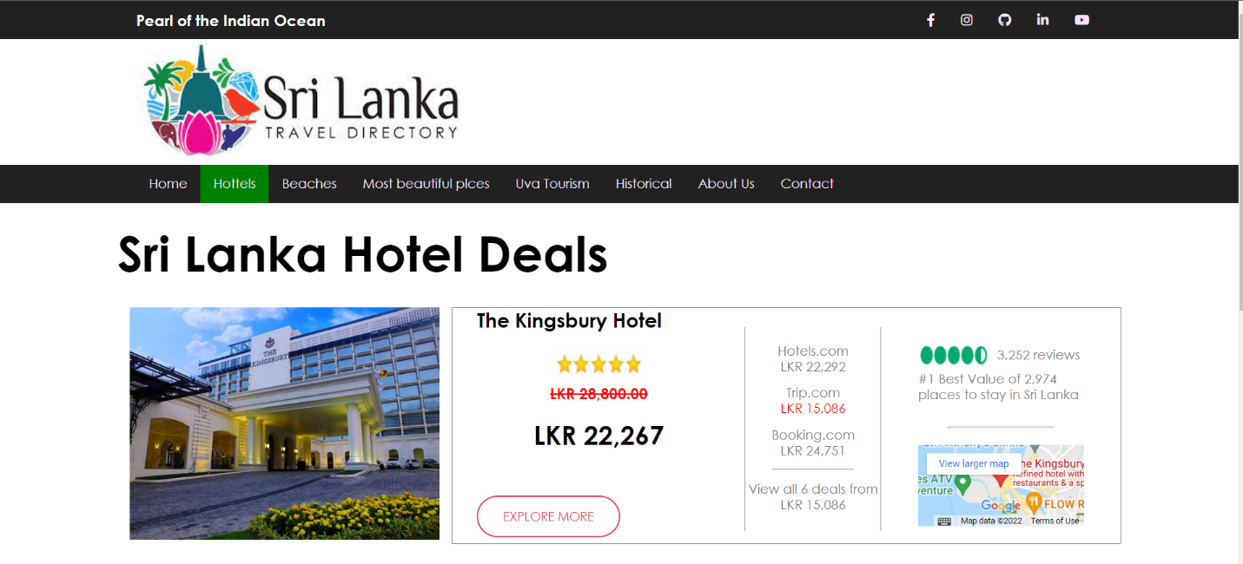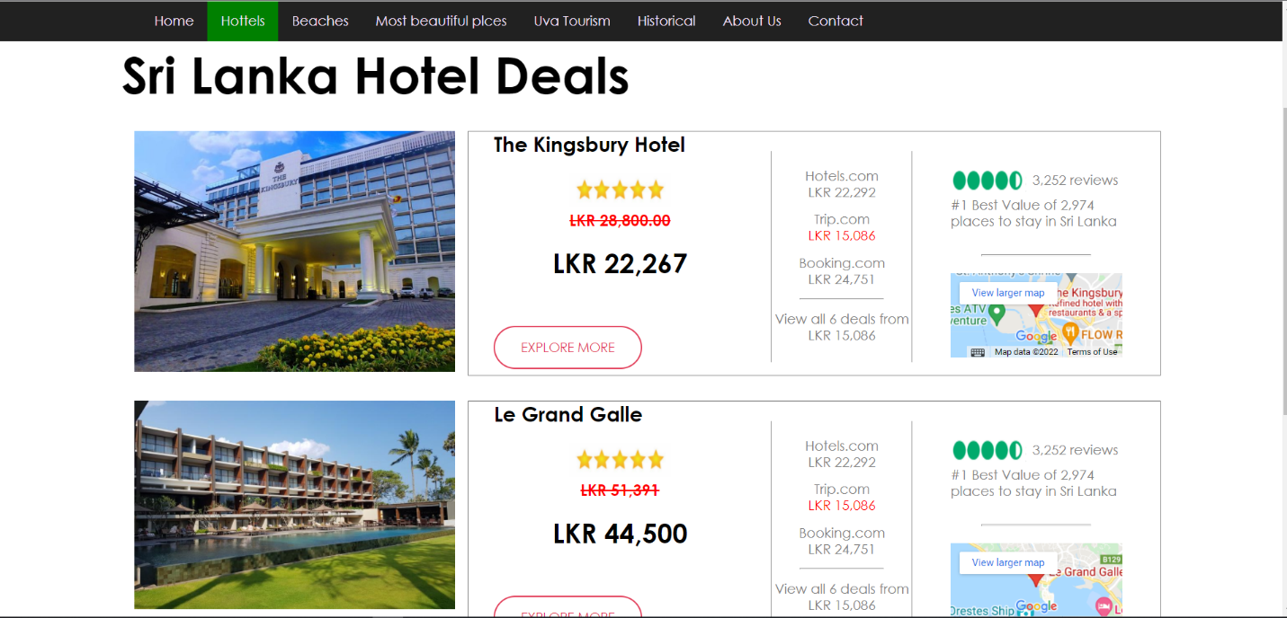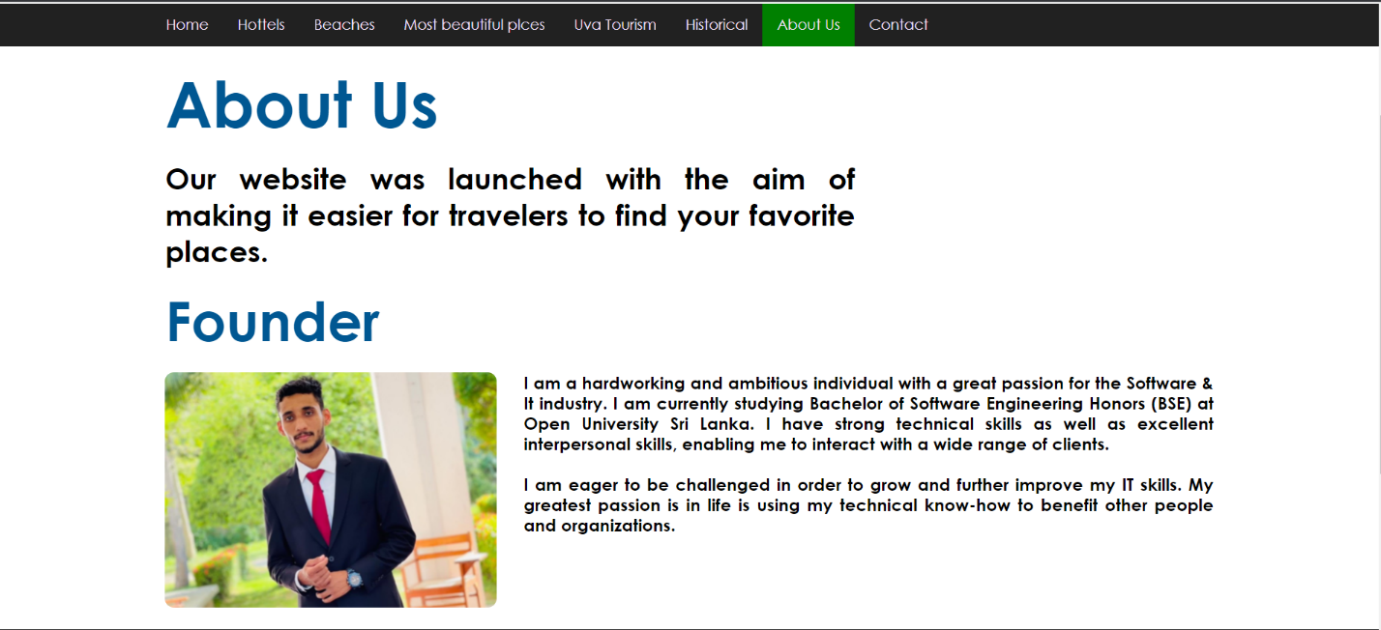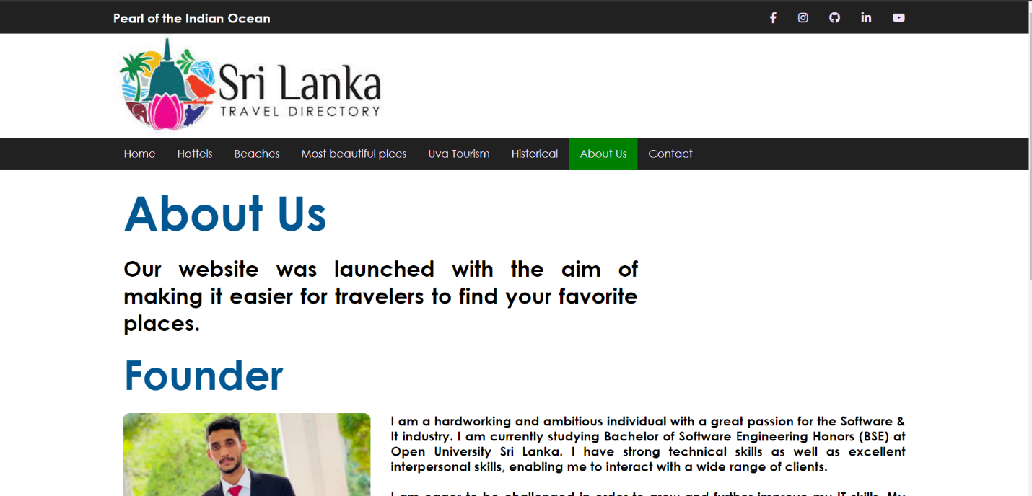

**References**

1. [**https://www.w3schools.com/**](https://www.w3schools.com/)
2. [**https://stackoverflow.com/**](https://stackoverflow.com/)
3. [**https://www.srilanka.travel/**](https://www.srilanka.travel/)

**Thank You!**